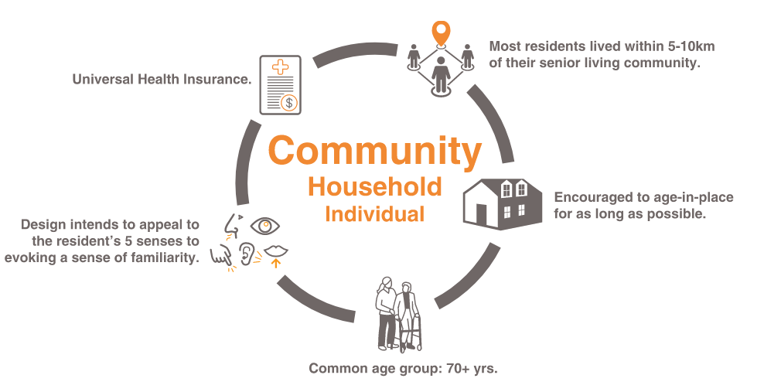

Wenz Tuttle 2018-2019: Senior Living

In 2018, I was awarded the 2018 AIA AAHF George J. Mann AIA Travel Prize which allowed me to embark on a 27-day journey to Japan. During my visit, I explored more than 15 senior and assisted living facilities of various architectural typographies, seeking an international perspective on how cultural influences shape design. Throughout my trip, I studied the spectrum of housing options available in Japan and assessed how well the designs catered to the needs of the elderly. From day-care facilities to intensive care nursing homes, Japan's diverse accommodations provided valuable insights that I could apply to the United States.

My project unfolded in three distinct phases. The first phase involved qualitative in-field observational research in Japan as part of the Mann Travel Prize. In the second phase, I documented and analyzed facilities visited and formatted the information into case studies. The final phase involved implementing the design concepts in a prototypical project known as Seasons Village, that was completed during my time as Tradewell Fellow at EYP/Page.

